1.Enviroinment Setup,Project Structure and First Component
Project Structure:
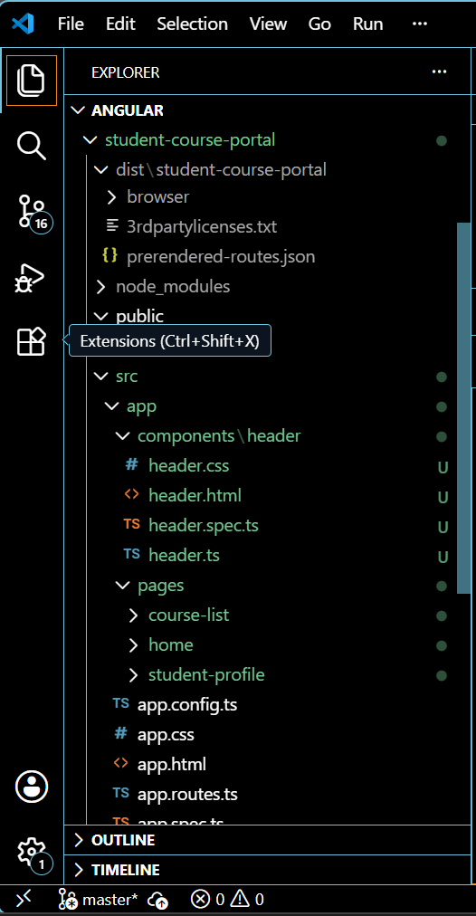

Angular.json
{
"$schema": "./node_modules/@angular/cli/lib/config/schema.json",
"version": 1,
"newProjectRoot": "projects",
"projects": {
"student-course-portal": {
"projectType": "application",
"schematics": {},
"root": "",
"sourceRoot": "src",
"prefix": "app",
"architect": {
"build": {
"builder": "@angular/build:application",
"options": {
"browser": "src/main.ts",
"polyfills": [
"zone.js"
],
"tsConfig": "tsconfig.app.json",
"assets": [
{
"glob": "**/*",
"input": "public"
}
],
"styles": [
"src/styles.css"
]
},
"configurations": {
"production": {
"budgets": [
{
"type": "initial",
"maximumWarning": "500kB",
"maximumError": "1MB"
},
{
"type": "anyComponentStyle",
"maximumWarning": "4kB",
"maximumError": "8kB"
}
],
"outputHashing": "all"
},
"development": {
"optimization": false,
"extractLicenses": false,
"sourceMap": true
}
},
"defaultConfiguration": "production"
},
"serve": {
"builder": "@angular/build:dev-server",
"configurations": {
"production": {
"buildTarget": "student-course-portal:build:production"
},
"development": {
"buildTarget": "student-course-portal:build:development"
}
},
"defaultConfiguration": "development"
},
"extract-i18n": {
"builder": "@angular/build:extract-i18n"
},
"test": {
"builder": "@angular/build:karma",
"options": {
"polyfills": [
"zone.js",
"zone.js/testing"
],
"tsConfig": "tsconfig.spec.json",
"assets": [
{
"glob": "**/*",
"input": "public"
}
],
"styles": [
"src/styles.css"
]
}
}
}
}
}
}

Output:

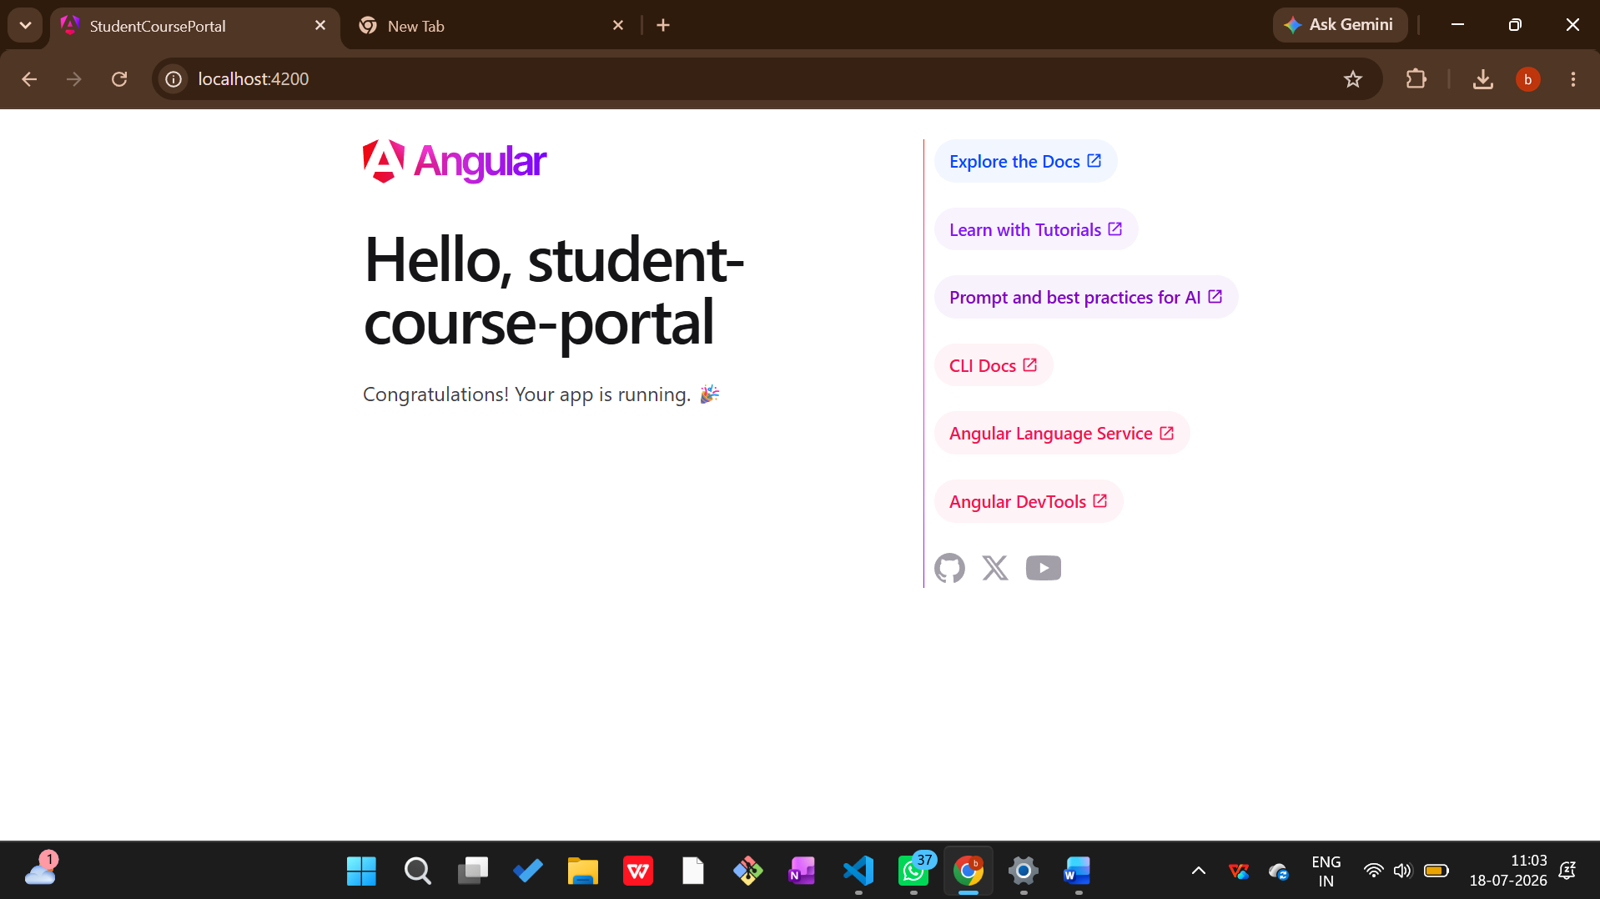
Terminal:
